A RESOURCE UNIT FOR GRADES THREE, FOUR AND FIVE

ENGLISH/LANGUAGE ARTS

SHAKESPEARE EDUCATIONAL TOUR

UNIT DESIGN COMMITTEE FOR ELEMENTARY

CONEJO VALLEY UNIFIED SCHOOL DISTRICT
INSTRUCTIONAL SERVICE DIVISION
Conejo Valley Unified School District
Shakespeare Educational Tour
Unit Design Committee for Elementary
Name Area of Specialization
Linda Hensley | Aspen ­ Elementary Administrator
Deanna Roth Neil | Meadows ­ Elementary Administrator
Snyder Amy | Ladera ­ Elementary Administrator
Brown Judy | Ladera ­ 2nd Grade
Levine Sheri | Ladera ­ 3rd Grade
Lund | Lang Ranch ­ 3rd Grad e
Ann Oppenheim | Ladera ­ 3rd Grade
Carol Scott | Ladera ­ 3rd Grade
Dick Martin | Ladera ­ 4th Grade
Ann Marie Matter | Lang Ranch ­ 4th Grade
Jennifer Fry DeDe | Meadows ­ 5th Grade
Burke Sue | Westlake Hills ­ GATE Instructor
Marrone | Shakespeare Educational Advisor

SHAKESPEARE EDUCATIONAL TOUR TABLE OF CONTENTS

Introduction……….......................................................................................................... 4 Purpose...........................................................................................................................5 Curriculum Outline ......................................................................................................... 9 Calendar .........................................................................................................................11 Parent Letter .................................................................................................................. 12 Pronouncing Vocabulary of Names.................................................................................13 It’s Not What You Say, But How You Say It....................................................................15 Lessons:
Day 1…………......................................................................................................16 Day 2.................................................................................................................... 23 Day 3.................................................................................................................... 40 Day 4.................................................................................................................... 47 Day 5 ­ 8...............................................................................................................49 Day 9.................................................................................................................... 50 Day 10.................................................................................................................. 53 Day 11.................................................................................................................. 55 Reference Materials ............................................................................................ 59

INTRODUCTION
The Shakespeare Educational Tour Unit is an educational experience about William Shakespeare and his works. The 2 – 3 week course of study for grades 3 – 5 include studies in history, the Globe Theater, a play and unique Shakespeare displays for your school. An interactive workshop for all students given by Shakespeare actors prior to a lecture demonstration performance will be given by the Kingsmen Shakespeare Company. The performance will include several scenes from the various plays of study. A question and answer session will be conducted after the performance by all the cast and crew. This unit complies with the English/Language Arts Framework for California Public Schools, K­12.
The English Language Arts Framework for California Public Schools, K­12 is based on the premise that all students will be provided an equal opportunity to become literate through participation in a comprehensive language arts program.
The content standards of the framework are:

- Reading ­ Word Analysis, Fluency, and Systematic Vocabulary Development and Comprehension
- Literacy ­ Response and Analysis
- Writing ­ Writing Strategies, Writing Application
- Grammar and Usage ­ Written and Oral English Language Conventions
- Listening and Speaking ­ Listening and Speaking Strategies
- Using Information ­ Application of Language

All of the content standards interact within the curriculum, with none wholly independent of the rest. The knowledge provided by the study of these content standards will enable the students to:
- acquire basic and advanced reading skills which enable them to comprehend increasingly complex and sophisticated material.
- acquire a core of knowledge about ideas, people and literature.
- appreciate a core of knowledge about ideas, people and literature.
- appreciate the beauty and power of language.
- listen and speak in a variety of situations and engage in discussions.
- write clearly and effectively for a variety of purposes.
- acquire study and research skills to access and communicate ideas in a technological society.
- become life­long readers and writers.

The English/Language units developed by the district implement the focus and goals of the state framework and reflect the content standards and goals as stated in the Coneio Vallev Unified School District K ­ 12 English/Language Arts Code and Sequence (4/15/97).

SHAKESPEARE EDUCATIONAL TOUR UNIT DESIGN PURPOSE
The purpose of this unit is to help the student begin to think about William Shakespeare's life, his works and the history surrounding the period. Each grade level will be introduced to William Shakespeare as a playwright and an outstanding poet through various works. Emphasis will be placed on one Shakespearean play at each grade level.

ENGLISH/LANGUAGE ARTS CONTENT STANDARDS
FOCUS IN
SHAKESPEARE CURRICULUM GRADES 3, 4, & 5
- Reading Standard:
The student reads and comprehends a wide range of print and non-print texts to:
- acquire new information
- respond to the needs of society and the workplace
- foster personal fulfillment

GOALS:
- Grade 3:
  - express ideas in the student's own words and make connections to related topics, information and real life.
    - students write a letter to Queen Elizabeth.
- Grade 4:
  - read and express understanding of a variety of informational texts.
    - students read play scripts.
- Grade 5:
  - summarize, express in own words, and make connections to related topics, information and real life.
    - students compare William Shakespeare to business of today.

- Literature Standard:
The student responds to fiction, nonfiction, poetry, and drama using interpretive, critical, evaluative and reflective processes, oral and written presentations.

GOALS:
- Grade 3:
  - participate in discussions and make varied responses regarding story elements: such as characters, events, point of view, author's purpose and themes.
    - students respond to the story elements in Burdett's Midsummer Night's Dream.
- Grade 4:
  - participate in discussions and make varied responses regarding story elements: such as characters, events, point of view, author's purpose and themes.
    - students respond to the story elements in Burdett's The Tempest.
- Grade 5:
  - participate in discussions and make varied responses regarding story elements: such as characters, events, point of view, author's purpose and themes.
    - students respond to the story elements in Burdett's Twelfth Night.

- Writing Standard:
The students produce various types of writing such as autobiographical incidents, stories, firsthand biographies, observations, problems/solutions, evaluations, speculations, controversial issues, and interpretations.

GOALS:
- Grade 3:
  - write in content areas.
    - students discuss, write, and share ideas about being a theater goer and sitting in various parts of the Globe Theatre.
- Grade 4:
  - write in content areas.
    - students discuss, write, and share ideas about being a theater goer and sitting in various parts of the Globe Theatre.
- Grade 5:
  - write in content areas.
    - students discuss, write, and share ideas about being a theater goer and sitting in various parts of the Globe Theatre.

- Grammar & Usage Standard:
The students use appropriate conventions of oral language which include grammar and usage of standard spoken English, conventional sentence structure of spoken English, and vocabulary for specific audiences and settings.

GOALS:
- Grade 3:
  - use language which is clear and appropriate for communicating to the intended audience.
    - students draw, write, and share storyboard/filmstrip.
- Grade 4:
  - use language which is clear and appropriate for communicating to the intended audience.
    - students draw, write, and share storyboard/filmstrip.
- Grade 5:
  - use language which is clear and appropriate for communicating to the intended audience.
    - students draw, write, and share storyboard/filmstrip.

- Listening & Speaking Standard:
The student applies knowledge of language structure, language conventions, media techniques, figurative language, and genre and responds to information and ideas.

GOALS:
- Grade 3:
  - show respect for other speakers.
    - students role play various parts in A Midsummer Night's Dream; audience courtesy is encouraged.
- Grade 4:
  - show respect for other speakers.
    - students role play various parts in The Tempest; audience courtesy is encouraged.
- Grade 5:
  - show respect for other speakers.
    - students role play various parts in Twelfth Night; audience courtesy is encouraged.

- Using Information Standard:
The students recognize and use logical arguments and persuasive strategies that reflect appropriate knowledge, background, and understanding of the intended audience.

GOALS:
- Grade 3:
  - participate in guided and independent discussions to promote effective comprehension strategies and higher order thinking.
    - students discuss various characters in the play, and how those characters affect the play.
- Grade 4:
  - demonstrate understanding of the logical arguments supporting different points of view
    - students discuss which character they see themselves most being, and why they see themselves as that character
- Grade 5:
  - utilize logical arguments supporting different points of view
    - students discuss how they would change the story to have a different ending

Shakespeare Curriculum Outline

Two Week Study
Day 1 Beginning Shakespeare for all grade levels
          - Who is William Shakespeare?
          - History
          - Blackline master Queen Elizabeth I
Day 2 Understanding the Globe Theatre for all grade levels
          - History behind the theater and its audience
          - Sketch of outdoor theater
          - Theater map of London
          - Scenery, stage properties and costumes
          - Effects on today's society
Day 3 Story
- Read grade level story
- Grade 3: Midsummer Night's Dream by Lois Burdett
  - Plot, Conflict. Setting, Characters
- Grade 4: The Tempest by Lois Burdett
  - Plot, Conflict, Setting, Characters
- Grade 5: Twelfth Night by Lois Burdett
  - Plot, Conflict, Setting, Characters
Day 4 Review & view video of grade level story
- Review day before
- Plot, Conflict, Setting, Characters
- View Video
- Discussion
Day 5 - 8 Read grade level script of play
- Read script aloud and role play characters
- Vocabulary & language
- Discussion questions
Day 9 Sequencing
          - Storyboard
          - Film strip
Day 10 Movie poster for plays
Day 11 Scheduled performance and workshop with Kingsmen Shakespeare Company (performance and workshop scheduled by principal)
Day 12 Optional assessment questions for all grade levels
Day 12 - 15 Extension Activities
          - Banners
          - Building a puppet theatre & puppets
          - Dances
          - Music

Shakespeare Unit Calendar Grades 3­5
Day 1 | Day 2 | Day 3
Introduction to William Shakespeare | Introduction to the Globe Theater | Discuss characters
Introduction to vocabulary and language | Work on vocabulary and language | Work on vocabulary and language
Read Burdett | Read Burdett | Read Burdett
Day 4 | Day 5 | Day 6
Discuss plot, conflict, and setting | Read play: Act 1 | Read play: Act II, III
Show video of play; compare | Reinforce vocabulary and language | Reinforce vocabulary and language
Read Burdett | Read Burdett | Read Burdett
Day 7 | Day 8 | Day 9
Read play: Act IV, Act V | Final Assessment | Extension Activity: Sequencing ­storyboard, filmstrip
Reinforce vocabulary and language
Discussion questions

Dear Parents:
Your child will soon experience a unit on William Shakespeare that is a joint project between the Conejo Valley Unified School District and the Thousand Oaks Arts Commission. The purpose of this unit is to introduce elementary age students to Shakespeare's life and works in an historical context. The "Shakespeare Educational Tour Program" involves an integrated experience incorporating English Language Arts (listening, speaking, reading and writing) and Visual & Performing Arts (art, music, dance and theatre).
During this 2­3 week unit, students in grades 3, 4 & 5 will study the development of the Globe Theater and explore Shakespeare's contribution as a poet, playwright and actor. The unit will culminate with an interactive workshop conducted by professional actors from the Kingsmen Shakespeare Company. The actors will also perform several scenes from one of Shakespeare's plays and students will have the opportunity to ask questions to the company.
Each grade level has an emphasis on one Shakespeare play:
Grade 3: A Midsummer Night's Dream
Grade 4: The Tempest
Grade 5: Twelfth Night
Students will learn about the setting, characters, plot and conflict of the play by reading adaptive versions of the stories and through class discussion, written assignments and visual arts experiences.
The anticipated outcome of our Shakespeare unit is that exposure to the greatest playwright and poet of the English language will serve to broaden students' cultural awareness and increase their enjoyment of great literature. It is also our hope that students will have a positive personal response as they experience the power of Shakespeare's words and ideas in their original dramatic format.
Sincerely,

Pronouncing Vocabulary of Names
a,e,i,o,u — as in hat, bet, it, hot, hut;
ā,ē,ī,ō,ū — as in ate, mote, mite, mote, mute;
ạ — as in America, freeman, coward;
ẽ — as in her, fern;
ũ — as in burn, furl.
Adriana (ad-ri-ā'-nạ)  Ægeon (ē'-ge-on)  Æmilia (ē-mil'-i-ạ)  Alcibiades (al-si-bī'-ạ-dēz)  Aliena (ā-li-ē'-nạ)  Angelo (an'-je-lō)  Antioch (an'-ti-ok)  Antiochus (an-tī'-o-kus)  Antipholus (an-tif'-o-lus)  Antonio (an-tō'-ni-ō)  Apemantus (ap-e-man'-tus)  Apollo (ạ-pol'-ō)  Ariel (ā'ri-el)  Arragon (ar'-ạ-gon)  Banquo (ban'-kwō)  Baptista (bap-tis'-tạ)  Bassanio (bas-sā'-ni-ō)  Beatrice (bē'ạ-tris)  Bellario (bel-lā'-ri-ō)  Bellarius (bel-lā'-ri-us)  Benedick (ben'-e-dik)  Benvolio (ben-vō'-li-ō)  Bertram (bẽr'-tram)  Bianca (bē-an'-kạ)  Borachio (bō-rach'-i-ō)  Brabantio (brạ-ban'chō)  Burgundy (bũr'-gun-di)  Caliban (kal'-i-ban)  Camillo (kạ-mil'-ō)  Capulet (kap'-ū-let)  Cassio (kas'-i-ō)  Celia (sē'-li-ạ)  Centaur (sen'-tawr)  Cerimon (sē'-ri-mon)  Cesario (se-sā'-ri-ō)  Claudio (klaw'-di-ō)  Claudius (klaw'-di-us)  Lafeu (lah-fũ')  Lear (lēr)  Leodovico (lē-ō-dō'-vi-kō)  Leonato (lē-ō-nā'-tō)  Leontes (lē-on-tēz)  Luciana (lū-shi-ā'nạ)  Lucio (lū'-shi-ō)  Lucius (lū'-shi-us)  Lucullus (lū-kul'-us)  Lysander (lī-san'-dẽr)  Lysimachus (lī-sim'-ạ-kus)  Macbeth (mak-beth')  Magdalen (mag'-dạ-len)  Malcolm (mal'-kum)  Malvolio (mal-vō'li-ō)  Mantua (man'-tū-ạ)  Mariana (mah-ri-ā'-na)  Menaphon (men'-ạ-fon)  Mercutio (mẽr-kū'-shi-ō)  Messina (mes-sē'-nah)  Milan (mil'-ạn)  Miranda (mī-ran'-dạ)  Mitylene (mit-ē-lē'-nē)  Montagu (mon'-tạ-gū)  Montano (mon-tah'-nō)  Oberon (ob'-ẽr-on)  Olivia (ō-liv'-i-ạ)  Ophelia (ō-fēl'-i-ạ or o-fēl'-yạ)  Orlando (awr-lan'-dō)  Orsino (awr-sē'-nō)  Othello (ō-thel'-ō)  Parolles (pã-rol'-ēz)  Paulina (paw-lī'-nạ)  Pentapolis (pen-tap'-o-lis)  Perdita (pẽr'-di-tạ)  Pericles (per'-i-klēz)  Petruchio (pe-trū'-chi-ō)  Phœnix (fē'-niks)  Pisanio (pē-sah'-ni-ō)  Polixines (pō-liks'-e-nēz)  Polonius (pō-lō'-ni-us)  Portia (pōr'-shi-ạ)  Proteus (prō'-te-us or prō'-tūs)  Regan (rē'-gạn) | Cordelia (kawr-dē'-li-ạ)  Cornwall (kawrn'-wawl)  Cymbeline (sim'-be-lēn)  Demetrius (de-mē'-tri-us)  Desdemona (des-de-mō-nạ)  Diana (dī-an'-ạ)  Dionyza (dī-ō-nī'-zạ)  Donalbain (don'-al-bān)  Doricles (dor'-i-klēz)  Dromio (drō'-mi-ō)  Duncan (dung'-kạn)  Emilia (ē-mil'-i-ạ)  Ephesus (ef'e-sus)  Escalus (es'-kạ-lus)  Ferdinand (fẽr'-di-nand)  Flaminius (flạ-min'-i-us)  Flavius (flā'-vi-us)  Fleance (flē'-ans)  Florizel (flor'-i-zel)  Ganymede (gan'-i-mēd)  Giulio (jū'-li-ō)  Goneril (gon'-e-ril)  Gonzalo (gon-zah'-lō)  Helena (hel'-e-nạ)  Helicanus (hel-i-kā'nus)  Hercules (hẽr'kū-lēz)  Hermia (hẽr'mi-ạ)  Hermione (hẽr-mī'-o-nē)  Horatio (hō-rā'-shi-ō)  Hortensio (hor-ten'-si-ō)  Iachimo (yak'-i-mō)  Iago (ē-ah-gō)  Illyria (il-lir'-i-ạ)  Imogen (im'-o-jen)  Jessica (jes'-i-kạ)  Juliet (jū'li-et)  Laertes (lā-ẽr'-tēz)  Roderigo (rō-der'-i-gō)  Romano (rō-mah'-nō)  Romeo (rō'-me-ō)  Rosalind (roz'-ạ-lind)  Rosaline (roz'-ạ-līn)  Rousillon (rū-sē-lyawng')  Sebastian (se-bas'-ti-ạn)  Sempronius (sem-prō'-ni-us)  Simonides (sī-mon'-i-dēz)  Solinus (sō-lī'-nus)  Sycorax (sī'-ko-raks)  Syracuse (sir-ạ-kūs)  Thaisa (tha-is'-ạ)  Thaliard (thā'-li-ạrd)  Thurio (thū'-ri-ō)  Timon (tī'-mon)  Titania (tī-tan'-i-ạ)  Tybalt (tib'-ạlt)  Ursula (ũr'-sū-lạ)  Venetian (ve-nē'-shạn)  Venice (ven'-is)  Ventidius (ven-tid'-i-us)  Verona (vā-rō'-nạ)  Vicentio (vē-sen'-shi-ō)

"It's Not What You Say, But How You Say It"
Shakespeare is probably one of the most quoted people we know. His expressions have even become our everyday expressions. You will be amazed at how many expressions are familiar to you.

Directions: Read each quote from Shakespeare and see if you recognize it. Then, choose one quote to say orally in class using tone of voice, two gestures, and facial expressions to create the meaning.

'too much of a good thing (As You Like It)
To be, or not to be. that is the question. (Hamlet)
What's in a name? (Romeo and Juliet)
Eaten me out of house and home (Henry IV)
Knock, knock, who's there? (Macbeth)
Such stuff as dreams are made on (The Tempest)
For goodness' sake (Henry VIII)
Budge an inch (The Taming of the Shrew)
Neither rhyme nor reason (The Comedy of Errors)
To thine own self be true (Hamlet)
Dead as a doornail (Henry IV, Part II)
A lean and hungry look (Julius Caesar)
The game is up! (Cymbeline)
Green­eyed monster (Othello)
The apple of her eye (Love's Labour's Lost)
Sweets to the sweets (Hamlet)
Parting Is such sweet sorrow. (Romeo and Juliet)
All the world's a stage. (As You Like It)
Good riddance (Troilus and Cressida)

DAY 1

Grades 3, 4 and 5

Lesson: Beginning Shakespeare for All Grade Levels

- Who is William Shakespeare?
- History
- Blackline Master of Queen Elizabeth I

William Shakespeare Day #1 An Overview & History

- Who is William Shakespeare?
Ask, "Who is William Shakespeare?"
Possible responses: "A man who wrote Romeo and Juliet. A man who wrote plays. I don't know”.
Ask, "Have you heard of Hamlet, Romeo & Juliet, Julius Caesar, Much Ado about Nothing”? Say, "William Shakespeare not only wrote these plays but he also acted in and directed these and many more."

- Shakespeare the Man and Playwright
Read aloud, A Child's Portrait of Shakespeare by Lois Burdett.
Ask, "What do you think would happen if the Puritans had been able to prevent plays from being performed?" Suggested Response: "We probably would not be going to the movie theaters, plays. concerts, or etc. today. We may not even have TV or computers. Our entertainment would be much different."

Activity #1

Have students use a piece of paper and write a letter to Queen Elizabeth I (in their best Shakespearean penmanship) inviting her and her royal court to see his newest play. Draw a seal at the end that would best fit William Shakespeare's personality to close the letter.

or

Read aloud Bard of Avon: The Story of William Shakespeare by Diane Stanley and Peter Vennema or give the following brief history of William Shakespeare (activity following).

William Shakespeare was born to a middle­class family in the market town of Stratford­on­Avon on April 23, 1564. His father, John, was a glove maker who later became the mayor of Stratford. Both of his parents were illiterate. He probably saw his first play by the time he was 3 or 4 years old. William was the third of eight children and he was educated in the Stratford Grammar School where he learned Latin and other subjects for nine hours every day. Later, at the age of eighteen, he married Anne Hathaway, and he became a playwright and bard (a poet). They had three children: Susanna and twins, Hamnet and Judith.

In London, England in the 1580's, the Puritans wanted to ban plays and close theaters. They claimed that theaters corrupted the minds of the young. Queen Elizabeth I disagreed and supported the theater. She asked the Lord Chamberlain's Men to perform plays at her court in London. Shakespeare performed and wrote for this group of actors. He wrote plays about the people and history of England. By the year 1594, six of Shakespeare's plays were written and produced.

Originally. Shakespeare's plays were not written to be read as literature. The plays were written as scripts and poems to be used for performing for the London theatergoers and royalty. Shakespeare was careful not to have the plays printed because there were no copyright laws (ways of safeguarding his plays from being stolen by other playwrights and acting companies whose living depended on their scripts.)

After Queen Elizabeth I died, King James I took over the throne in 1603. The Lord Chamberlain's Men became known as the King's Men. They gave private performances for the king and court, and Shakespeare became a wealthy property owner, businessman, and gentleman.

In 1612, at age forty-eight, Shakespeare partially retired, and divided his time between a home in London and a home called New Place in Stratford. Finally, on April 23, 1616 at the age of fifty-two, Shakespeare died.

Shakespeare was a poet and playwright who made major contributions (with his 37 plays and 154 sonnets [poems with 14 lines]) to the creative arts, music, & dance. These fields were used to develop the stories he wanted to tell through his plays of history, comedy, and drama.

Today, Shakespeare's works have been translated into seventy-four or more languages.

Activity #2

Show pictures of William Shakespeare and Queen Elizabeth I.
Ask, "What makes Shakespeare look different from the typical businessman and playwright today?"
Responses:
Ask, "What is different about Queen Elizabeth’s fashion verses Queen Elizabeth of England's fashion today?"
Responses:

Hand out blank sheets of paper, and ask the students to draw Shakespeare and his costume in the 1580's. Then, have the students draw what he might look like in today's fashion.

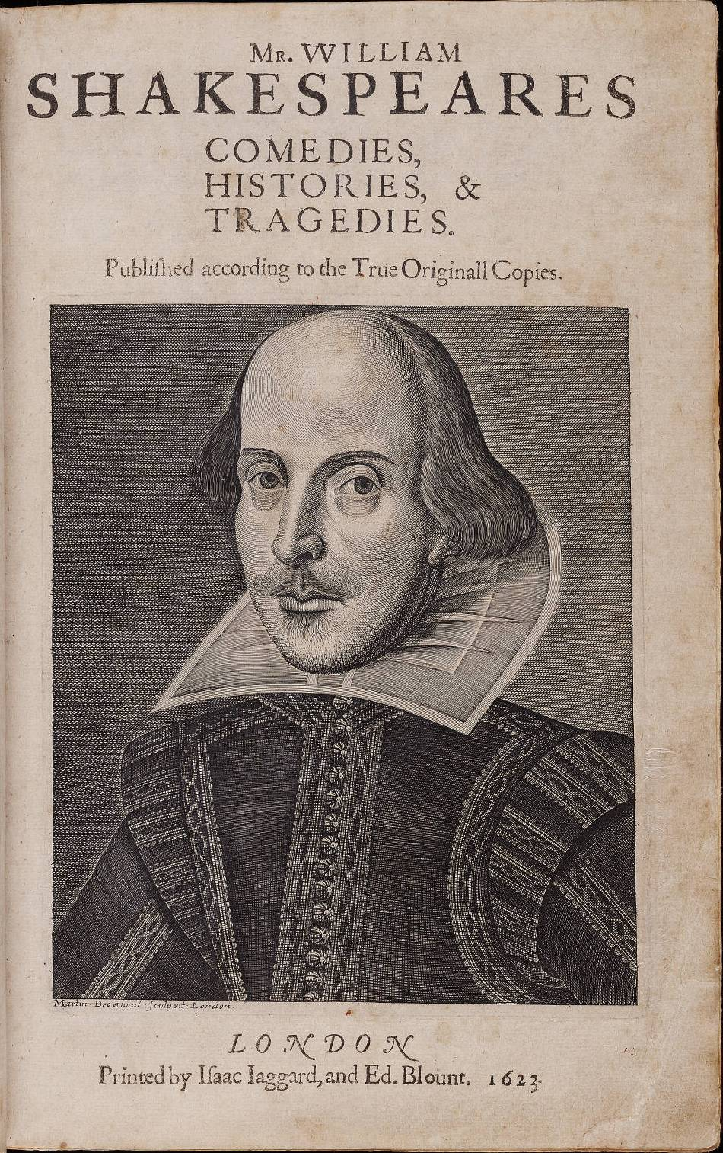

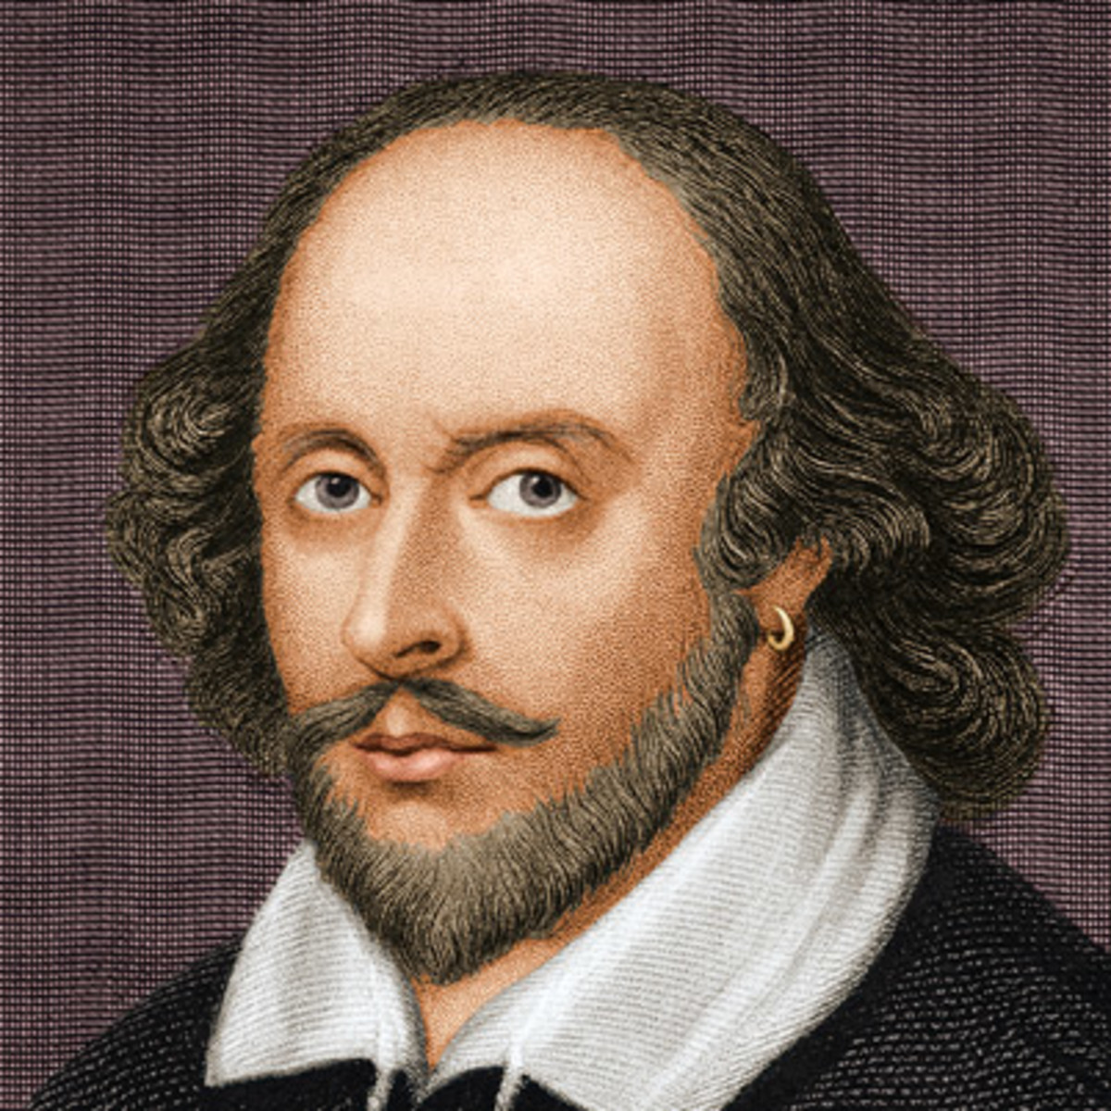

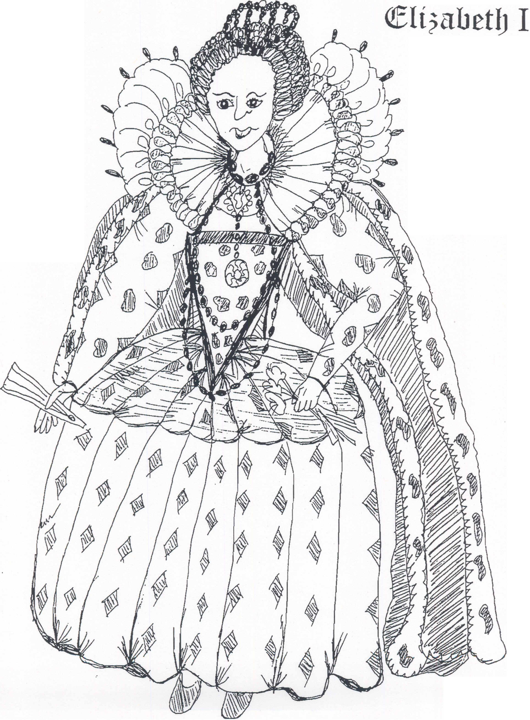

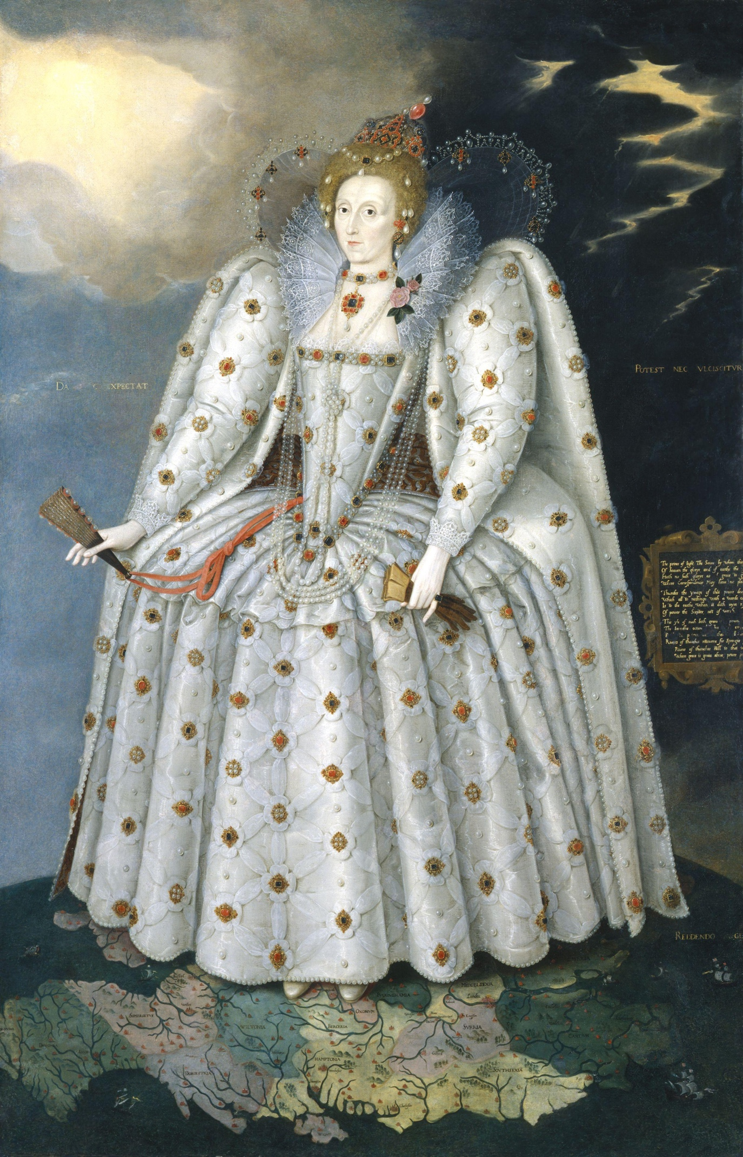

DAY 2

Grades 3, 4 and 5

Lesson: Globe Theater

- History behind theater & audience
- Sketch of outdoor theater
- Theater map of London
- Scenery, stage properties & costumes
- Effects on Today’s Society

William Shakespeare Day #2 The Globe Theater & the Elizabethan’s theater’s audience

- Background information for theater-going
Theaters were located on the outskirts of the city in slums, safely out of the jurisdiction of the county sheriff, mayor, and the city of London. These areas were called "Liberties" and were very different than our suburbs today. They were the perfect places for thieves and scoundrels.

The Globe Theatre was built in 1599 by Shakespeare and his associates. It was circular in shape like the bear­baiting and bull­baiting arenas.

note: bear­baiting and bull-baiting were popular but cruel forms of entertainment. The bear would be tied to a pole in the middle of a circular arena and dogs would be loosed on it.

It was an open-air playhouse built outside of London. The plays or performances took place in the afternoon to take advantage of the sunlight since there were no lights or electricity. Most of the potential playhouse audience lived on the north bank of the Thames River in the city of London. The people and theatergoers knew a performance was to begin shortly by a flag that was flown above the top of the theater. The audience would make their way over old London Bridge or they could pay a penny and catch a ferryboat. The audience bought their entrance just before show time for the admission price of one penny or pence, two pence, or three pence. If a person was willing to pay more, then he could take a seat and sit on the stage where he could badger the players. cheer for them, or shout warnings or insults. The "groundlings" were lower class citizens that crowded on the dirt floor inside the theater and they paid one pence. They crowded around the stage in the open-air areas. They stood during the entire performance, and they ate, yelled, wrestled, drank, and stunk from body odor & bad breath. They were referred to as the "penny stinkard." Those that paid two pence or three pence bought seats on the upper levels with thatched roofs over them in case of bad weather. They could refresh themselves at their own cost with food and drink that was carried around among the more expensive seats. The plays had to appeal to everyone in the audience to keep their interest.

The events surrounding the play were usually the same. The play began with the sound of trumpets which heralded or called the actor to deliver the prologue. He would appear on stage to summarize what was about to take place for the audience. At the end. the stage was filled with singers, acrobats, and tumblers for the finale even if the play's ending was sad and somber.

Three years before Shakespeare died, the Globe Theatre burned to the ground in 1613 during a performance of Henry VIII. It was rebuilt on the same spot in a far fairer manner than before according to John Heminges who was responsible for the financing of the rebuilding.

note: no women or girls acted in the plays. All women's or girl's roles were played by young men or boys. For women or girls to act in a play would have been a serious breach of custom.

William Shakespeare's works are still read and enjoyed today! His works are translated into more than 70 languages. We love and appreciate Shakespeare because he created real people with real problems and real situations. His characters are people you and I can relate to and recognize. The characters are foolish, yet tragic; love-struck yet treacherous; cowardly, yet sly and shrewd; gullible, yet wise. The characters and his works are part of our language and Shakespeare is ageless and relevant. We hear him quoted throughout life whether on television, radio, written works, or people just trying to make a point. He put the humanity into human. He is the greatest pioneer of true theater today!

Today our society and lives are enhanced because of Shakespeare's insight and bravery to be on the cutting edge in his day with new techniques for play writing and the theater. We have the privilege of the theater and its entertaining spark. Once you read, perform, and understand Shakespeare your life will be enhanced too.

Activity #1

Journal Writing: How do you think life would be different without Shakespeare? What are some possible things that we would be without if it were not for William Shakespeare using his gift for writing plays? How would entertainment be different today without Shakespeare?
Possible answers: We may not have TV today. We may not have movies or theater to attend today as a form of entertainment.

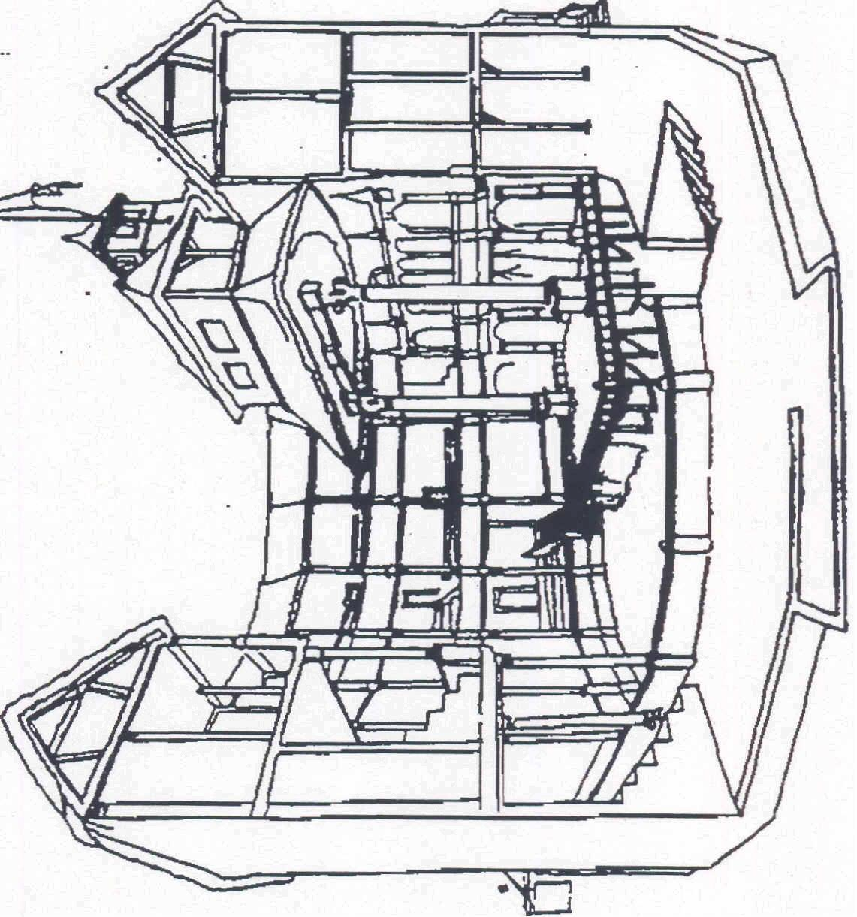

inner stage

middle gallery

entrance

corridor

lord’s room

main entrance

stage

the pit

hell

trap door

stage door

hut

flag

the heavens

wardrobe

gallery

stairs

tiring house

tiring house door

The Globe Theater was born out of a legal squabble and the need for a company of English actors to be assured of a permanent home. It became the most important theater to William Shakespeare. He wrote more than half of his 37 plays specifically for production at the Globe.
A predecessor playhouse – named simply “The Theater” – was used for more than 20 years by an acting company that became known as the Lord Chamberlain’s Men, Shakespeare joined that troupe between 1590 and 1592.
The owner of the land on which that earlier theater was built refused to renew the lease. So, the theater’s proprietors dismantled the structure and rebuilt it across the Thames River in a
southern London suburb called the Bankside. The relocated theater was named “The Globe”, and Shakespeare owned 10 percent of it. The acting company eventually was renamed, “The King’s Men”.
For 14 years, from 1599 to 1613, the Globe served as the main showcase for Shakespeare’s plays. He wrote with the dimensions of the Globe in mind; the building and the playwright complimented each other. Although it could accommodate 2,000 patrons – many of whom stood – the Globe’s design made it quite intimate. The main stage projected forward into the audience, and play goers viewed the action from three sides. Shakespeare capitalized on that sense of intimacy. Hamlet’s soliloquies, for example, worked well when the actor spoke while nearly surrounded by the Globe audience. Those soliloquies are harder to stage in many modern theaters.

The Globe burned down in 1613, when the thatched roof of the gallery was ignited by wandering fired from a cannon as part of a performance of Henry VIII. A more elaborate theater, also called the Globe, was built on the spot the next year. It was torn down in 1644, a victim of the new Puritan government that decided plays were immoral and should be banned. The Globe stood just 500 feet from the old London Bridge and many playgoers crossed the bridge on foot or in horse-drawn carriages. Others arrived at the theater via ferry boats that piled the Thames.
Each playgoer paid one penny to enter the Globe; that permitted him to watch the performance while standing in “the pit” on the ground floor. By paying additional pennies, a patron could climb to a seat in one of the three galleries. It wasn’t a stiff and formal occasion; some playgoers imbibed alcoholic beverages during the performance.
The theater’s designed focused attention not so much on how a single actor interpreted a role, but rather on a steady flow of action and an attempt to develop a sense of participation in the audience.
Although parts of the theater were roofed, the plays were performed essentially in the open air. During winter, the actors moved to an indoor theater. A white flag fluttering above the theater signaled everyone that a play would be given that day.

In the famous balcony scene between Romeo & Juliet, where would the two payers stand? (Juliet above the inner stage on a balcony called the chamber; Romeo on the stage below.)
The trap door near center stage was hinged and led to the cellar or “hell” under the stage. Sometimes the trap door became important to the play. In Hamlet, the playgoers met gravediggers singing at their work as they emerged from below stage. And the ghost of Hamlet’s father called out from the cellar.
Heavy and bulky props were stored in the cellar. Fragile props wouldn’t have lasted long there because it was quite damp. The Globe was built on drained swampland.
Globe plays had no intermissions. How did playgoers know when the scene was about to change? (Shakespeare often tipped off the audience by rhyming the last two lines before a scene change).
The Globe’s influence is still felt today. New theaters usually are constructed with an apron, a forestage that extends part way into the audience. Theater-in-the-round creates a sense of intimacy somewhat like that of the Globe.
So, although the Globe burned down more than three centuries ago, its impact lingers.

Activity

Ask, "What devices are employed today to achieve a sense of participation in an audience, either small or mass”.
Ask, "What devices the Globe actors might have employed to speed up the play’s action and achieve a sense of participation among the playgoers”.
Ask, "Does the stage have a curtain? If so, where?”
answer: "in front of the inner stage”.
Ask, "Where does the phrase “tiring house” come from?”.
answer: actors put on costumes there; they were “attired”.
Ask, "Would you rather watch the play as “groundlings” from “the pit” or buy a seat in the gallery? Why?”

Review with the students the parts of the Globe Theater. It is advisable to conduct an oral review before using a quiz format. A writing assignment may be given on the subject, “A day at the Globe Theater.”

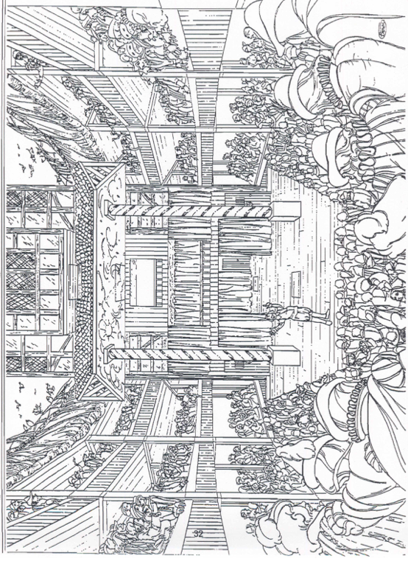

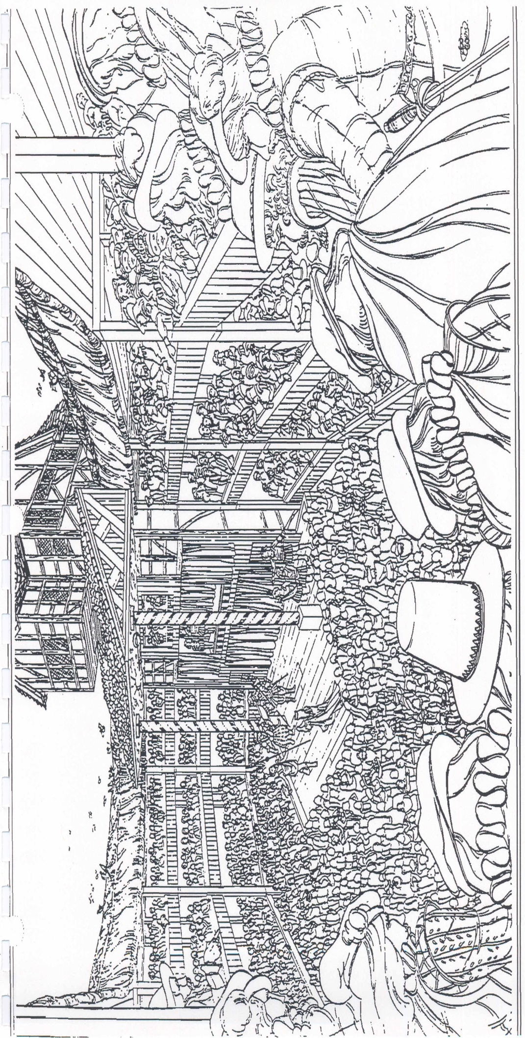

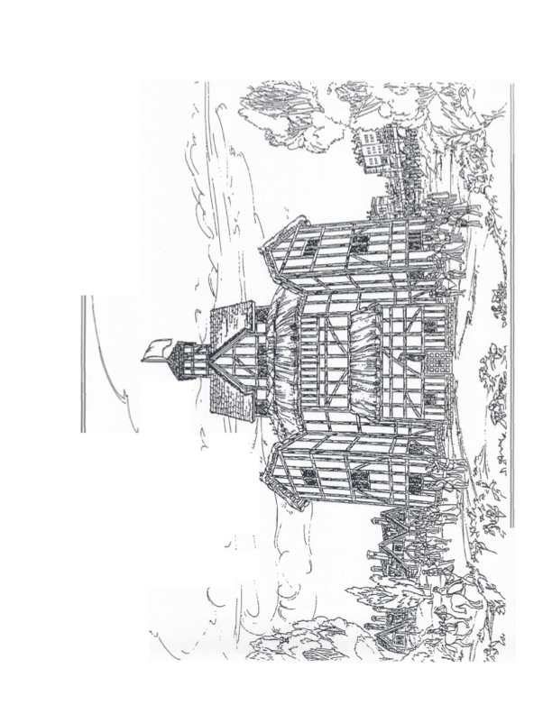

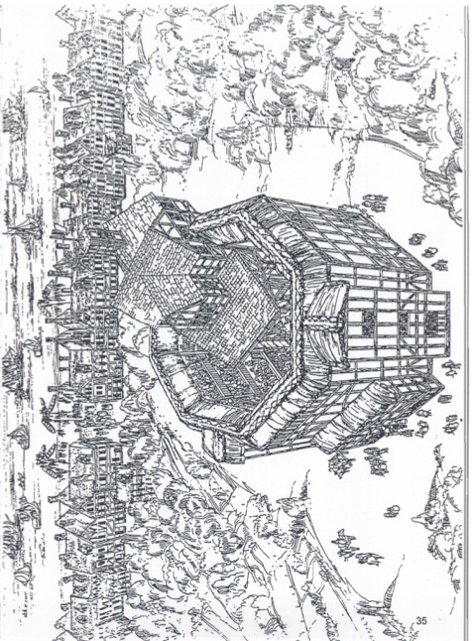

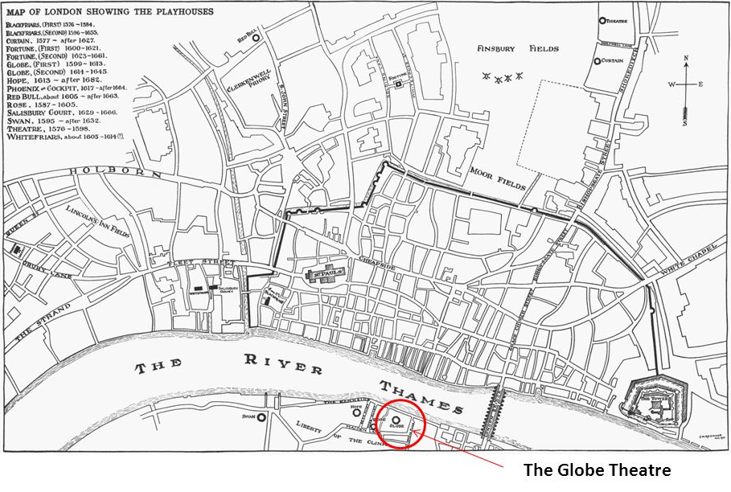

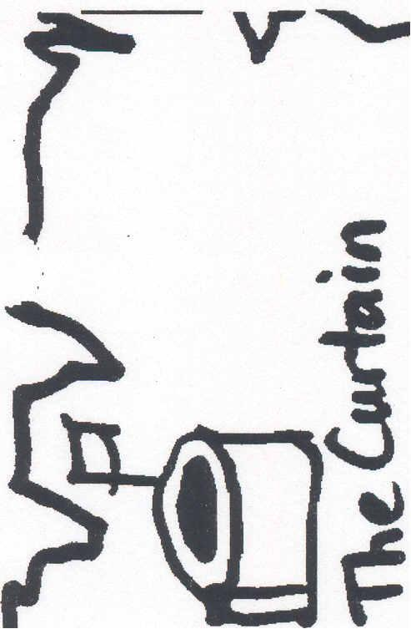
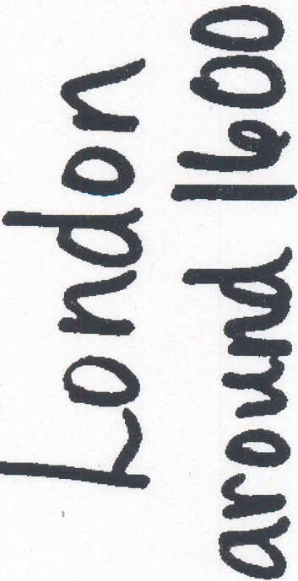
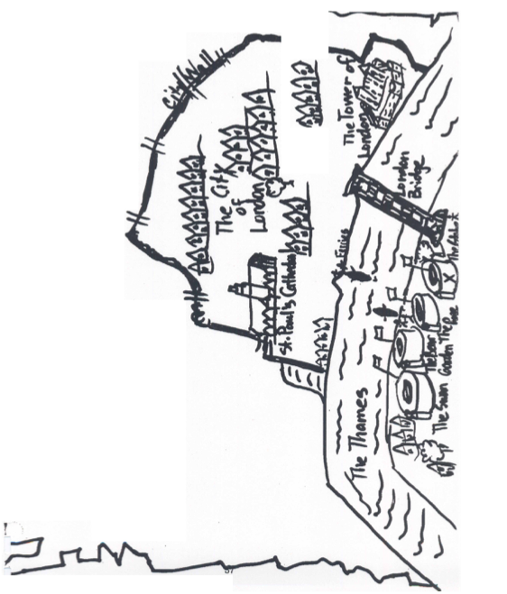

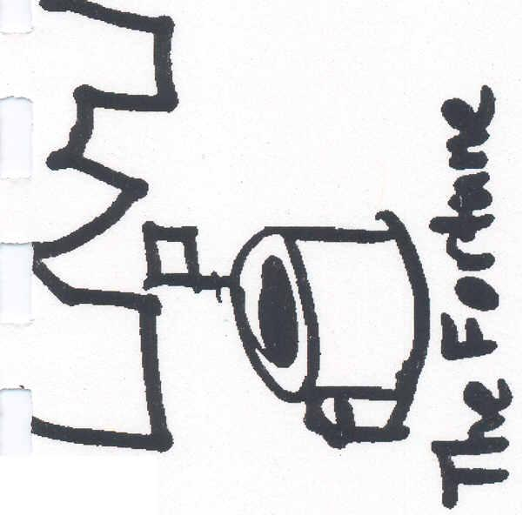

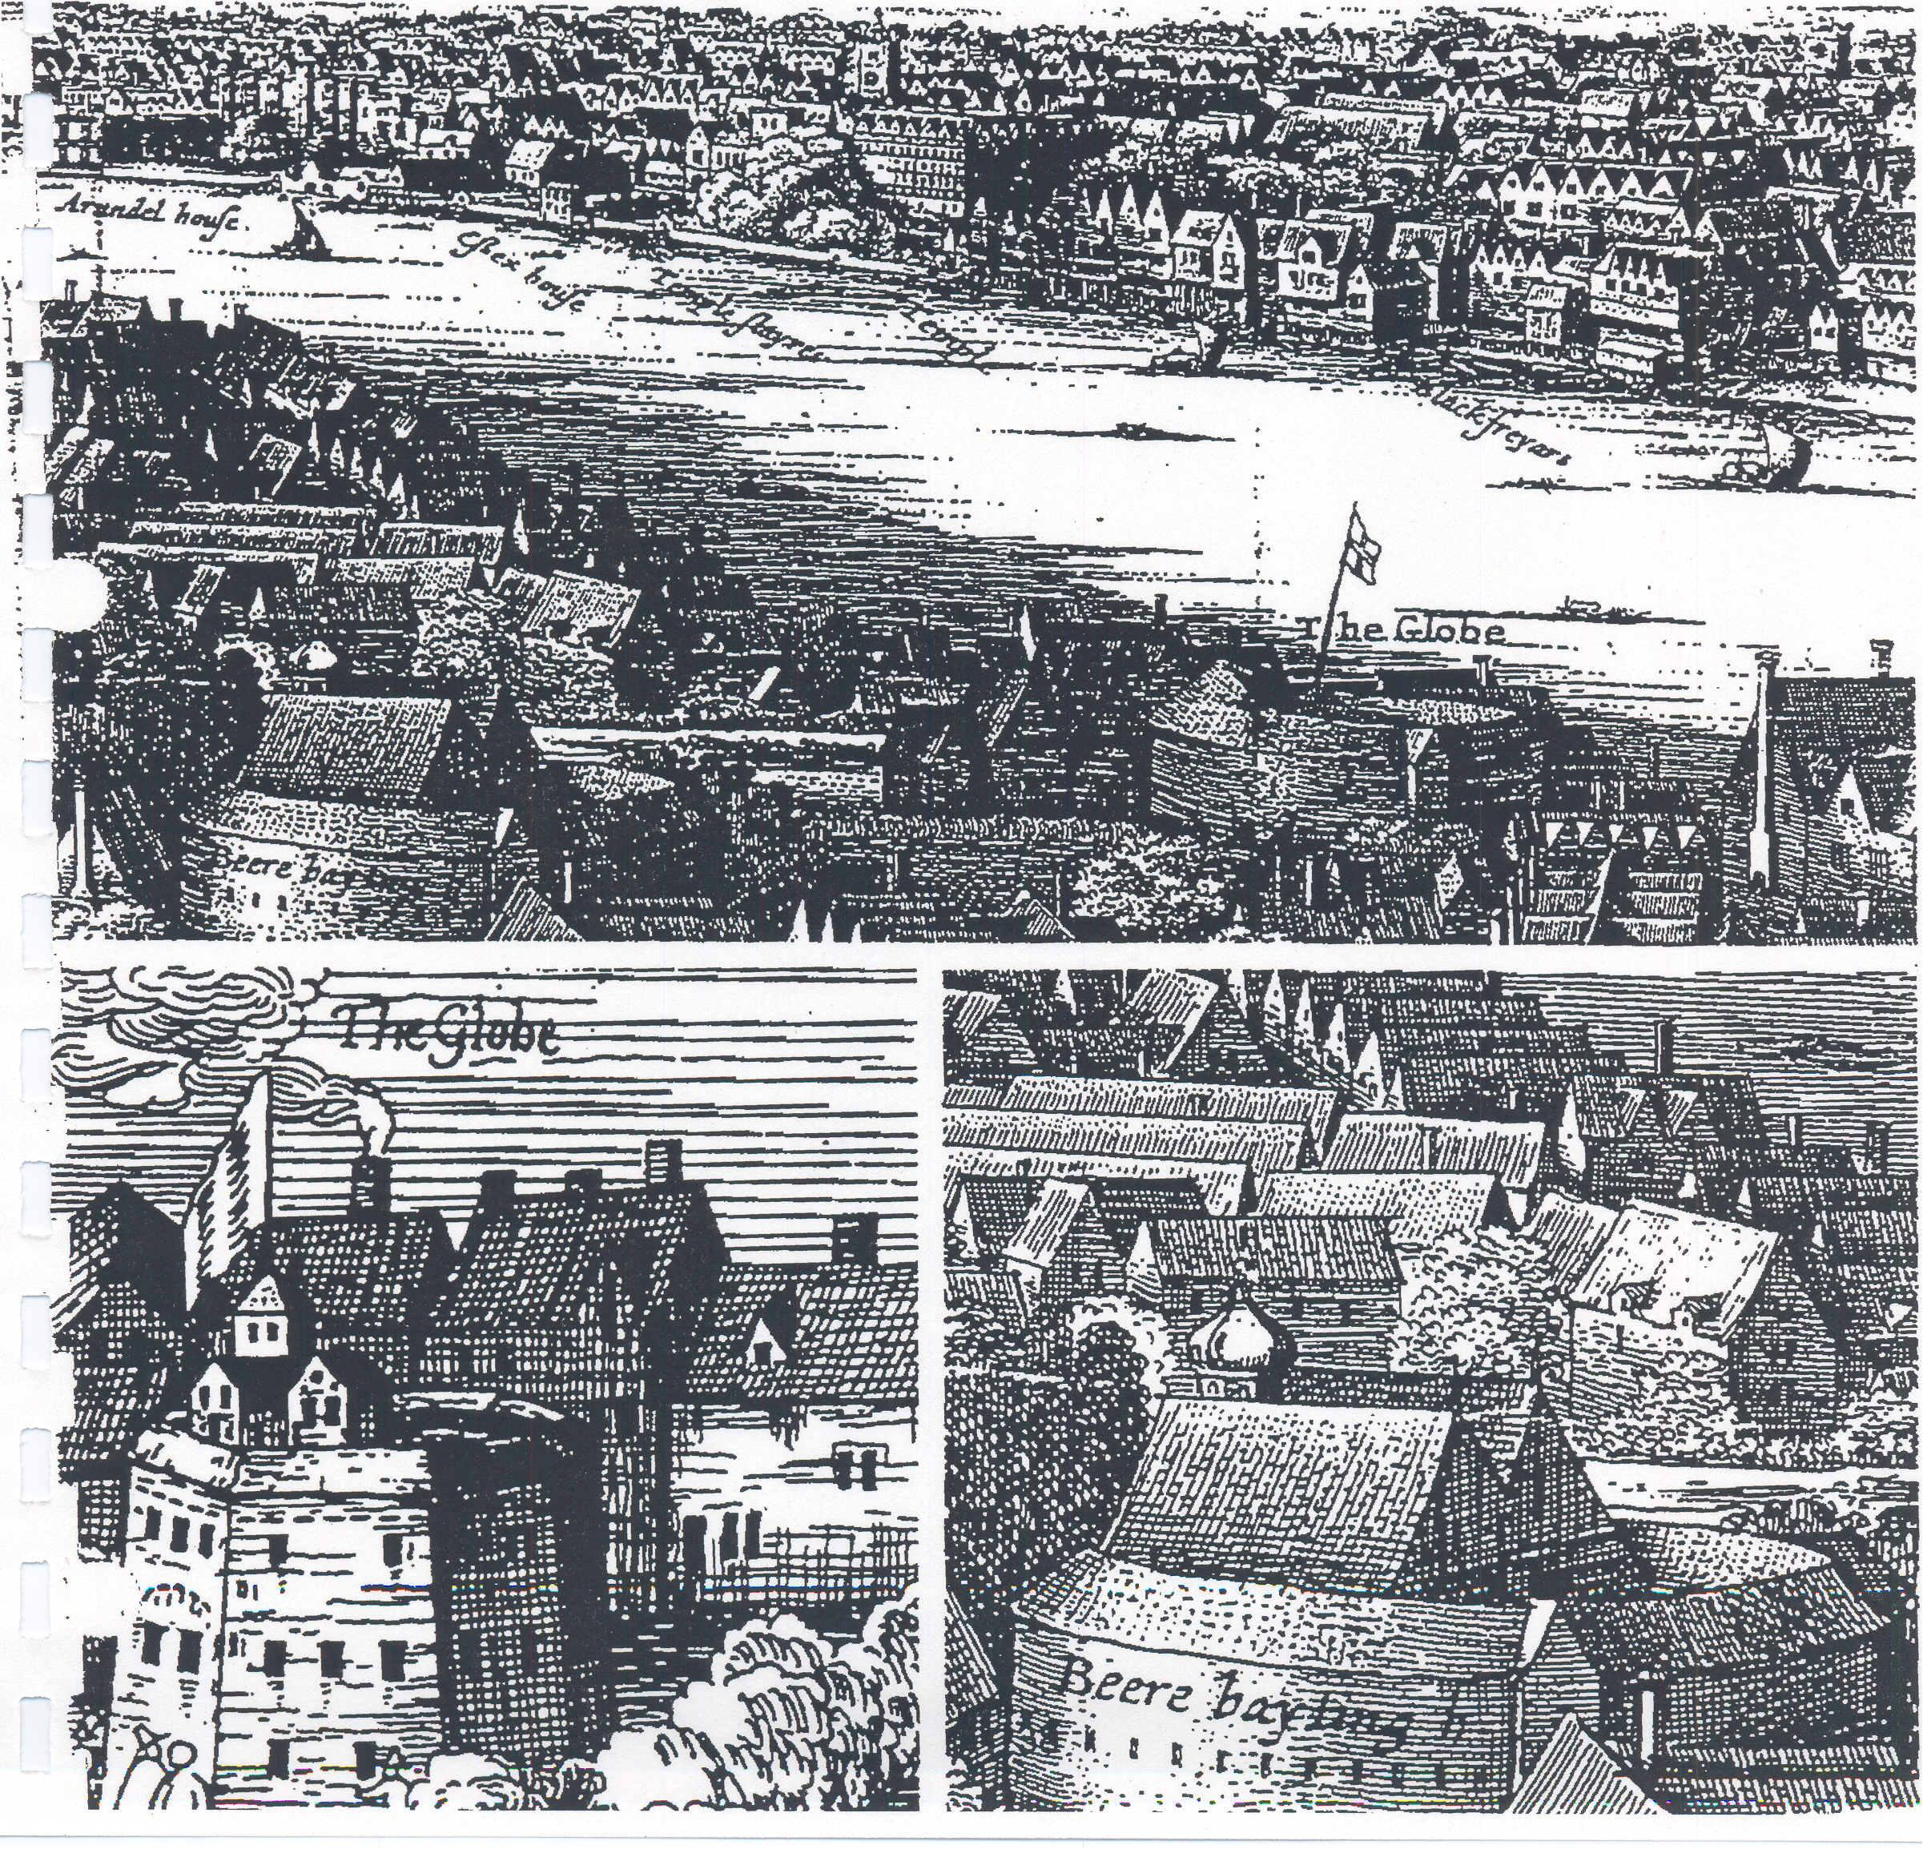

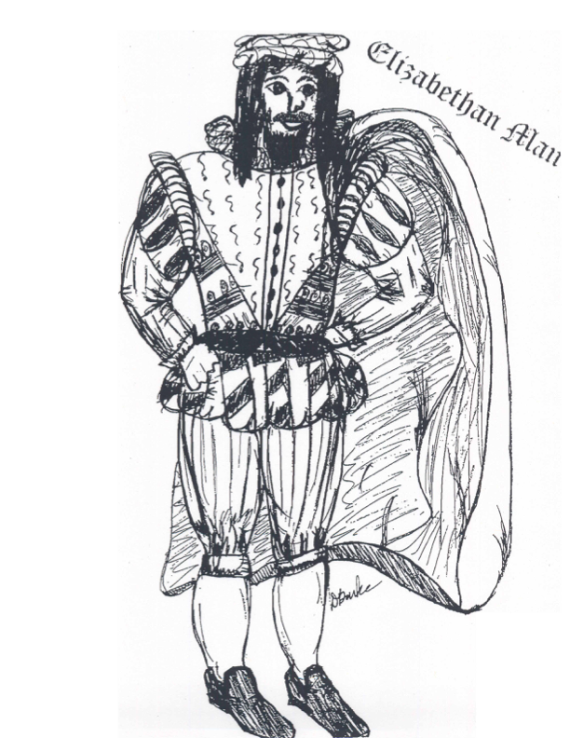

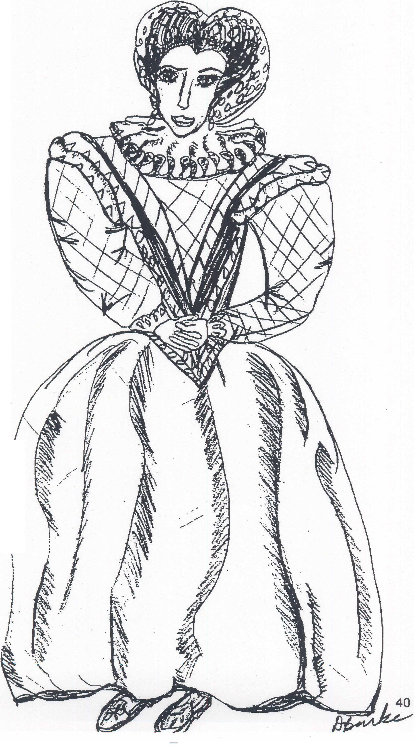
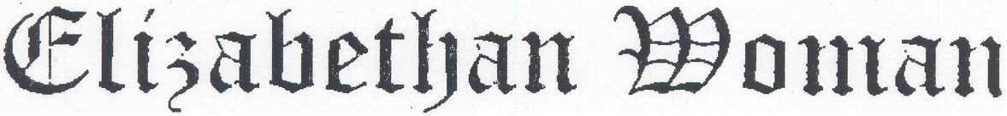

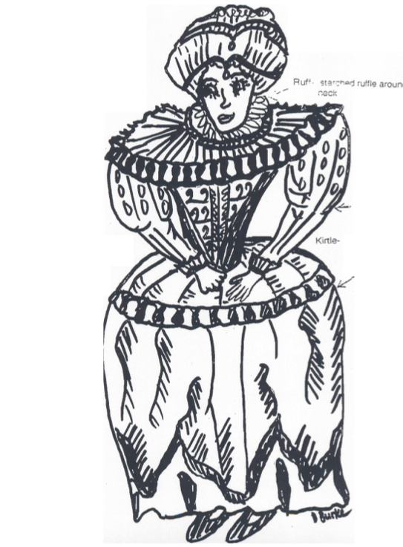

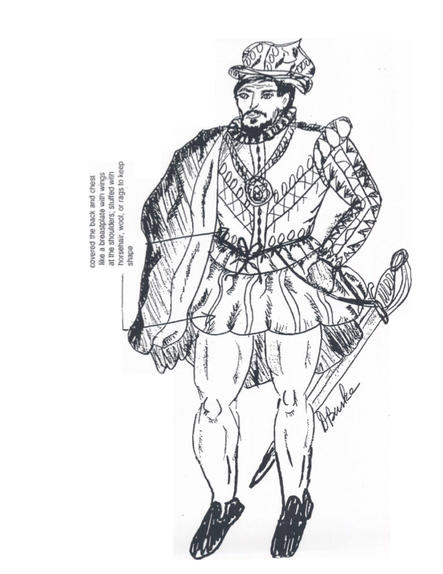

DAY 3

Grades 3, 4 and 5

Lesson: Read Grade Level Story

- Grade 3: A Midsummer Night’s Dream by Lois Burdett
  - Plot, Conflict, Setting, Characters
- Grade 4: The Tempest by Lois Burdett
  - Plot, Conflict, Setting, Characters
- Grade 5: Twelfth Night by Lois Burdett
  - Plot, Conflict, Setting, Characters

Midsummer Night's Dream

Setting:

Characters:

Plot:

Conflict:

Setting: long long ago

Place: a mystical island called Illyria

Characters:
Theseus – Duke of Athens
Hippolyta – Queen of the Amazons, engaged to Theseus
Egeus – Father of Hermia
Demetrius – in love with Hermia; later realizes he is in love with Helena
Lysander – in love with Hermia
Philostrate – Theseus’ entertainment advisor
Hermia – daughter of Egeus; in love with Lysander
Helena – in love with Demetrius
Quince – a carpenter
Snug – a joiner
Bottom – a weaver
Flute – a bellows-mender
Snout – a tinker
Starveling – a taylor
Oberon – King of the fairies
Titania – Queen of the fairies
Puck – a sprite

Plot: Egeus of Athens has chosen Demetrius as the man he wants his daughter to marry. But Hermia does not want to marry Demetrius, for she loves Lysander. Hermia’s friend Helena loves Demetrius – but he does not love her (for he loves Hermia). Somehow the lovers must find happiness, but that is no easy task. With the help (and hindrance) of Oberon and Titania – King and Queen of the fairies – and Puck, Oberon’s impish sidekick, perhaps a solution can found.

Conflict: Entangled love as – Demetrius loves Hermia, Hermia loves Lysander, Helena loves Demetrius.

The Tempest

Setting:

Characters:

Plot:

Conflict:

Setting: One night, a ship tossed on the sea during a terrific storm, or tempest. On board were Alonso, King of Naples; his brother Sebastian, his son Ferdinand; the duke of Milan, Antonio; his faithful counselor Gonzalo; and many others. Their ship wrecked upon the waves in view of a mystical island, and all were thrown into the sea.

Characters:
Alonso, King of Naples
Sebastian, Alonso’s brother
Prospero, the right duke of Milan
Antonio, Prospero’s brother, the usurping duke of Milan
Ferdinand, son to the King of Naples
Gonzalo, counselor to the King of Naples
Adrian, Francisco, lords from Milan
Caliban, a deformed slave
Trinculo, a jester
Stephano, a drunken butler
Miranda, daughter of Prospero
Ariel, an airy spirit

Plot: Prospero, the usurped duke of Milan, using his magic to regain his dukedom by causing a tempest which brings a ship arrying his evil brother, now duke of Milan, the king of Naples and other members of court to his mystical island. There, Prospero, with the help of the spirit Aerial torments the shipwrecked courtiers into thinking all is lost, especially the King, who believes his son Ferdinand, to be dead. However, Aerial has brought Ferdinand to Prospera where Ferdinand falls in love with Prospero’s daughter Miranda. Also all the island is Propero’s slave, Caliban, who with other crew members, plot to take the island’s rule from prospero. But with magic and the matured gift of forgiveness, Prospero brings all together and forgives all their sins towards him. In this great gesture, the king returns milan to prospreo’s rule, Ferdinand and Miranda marry and Caliban and Aerial are set free. Before Prospero leaves the island he breaks his magic stagg and drowns his amgic book.

Conflict: Power, release of power, and forgiveness
Liberty, love and wonder

Twelfth Night

Setting:

Characters:

Plot:

Conflict:

Characters:
Orsino – Duke of Illyria (in love with Olivia)
Olivia – a rich countess
Viola – Sebastian’s sister (in love with Duke Orsino)
Sebastian – Viola’s brother
Sir Toby Belch – Olivia’s uncle
Maria – Olivia’s chambermaid
Malvolio – Olivia’s steward
Antonio – a sea captain, Sebastian’s Friend
Sir Andrew Ague-cheek – Sir Toby’s friend
Valentine, Curio – gentlemen tending to the Duke
Fabian – Olivia’s servant
Clown – Olivia’s servant and jester

Plot: After being separated from her twin brother, Viola pretends to be a boy page in service of Orsino. She delivers love messages to the rich countess Olivia from Orsino, but Olivia (thinking she is a young man) falls in love with her instead. To confuse matters, Viola falls in love with the Duke, Orsino. Meanwhile at Olivia’s house, Olivia’s uncle and the servants are dreaming up ways to make the steward, Malvolio, look foolish. Viola’s lost twin brother shows up and everyone gets confused.

Conflict: Orsino loves Olivia, Olivia loves Viola, Viola loves Orsino

DAY 4

Grades 3, 4 and 5

Lesson: Review and View Video of Grade Level Story

- Review Day Before
  - Plot, Conflict, Setting, Characters
- Grade 3: A Midsummer Night’s Dream
- Grade 4: The Tempest
- Grade 5: Twelfth Night
- View Video
- Discussion

VIDEO QUESTIONS FOR ALL GRADE LEVELS
ANIMATED TALES
1992 Shakespeare Animated Films Limited' and Christmas Films Package 1993 by Random House. Inc. HBO 30 minutes

Questions:
1. Who are the characters?
2. What is the setting of the play?
3. Follow one character throughout the story. Discuss the effect of the story with or without the character in the scene.
4. What character do you see yourself as being in your life? What are some similarities and differences?
5. How would you change this story to have a different ending?
(Classroom Generated) Questions for Discussion:
6.
7.
8.

DAY 5 - 8

Grades 3, 4 and 5

Lesson: Read the Play

- Grade 3: A Midsummer Night’s Dream *
- Grade 4: The Tempest*
- Grade 5: Twelfth Night*
- Vocabulary and Language
- Discussion Questions

*Plays are in a separate packet

DAY 9

Grades 3, 4 and 5

Lesson: Sequencing

- Storyboard
- Filmstrip

Additional Study – Storyboard
Students create a storyboard or comic strip retelling the events in one scene of the play. See example below.

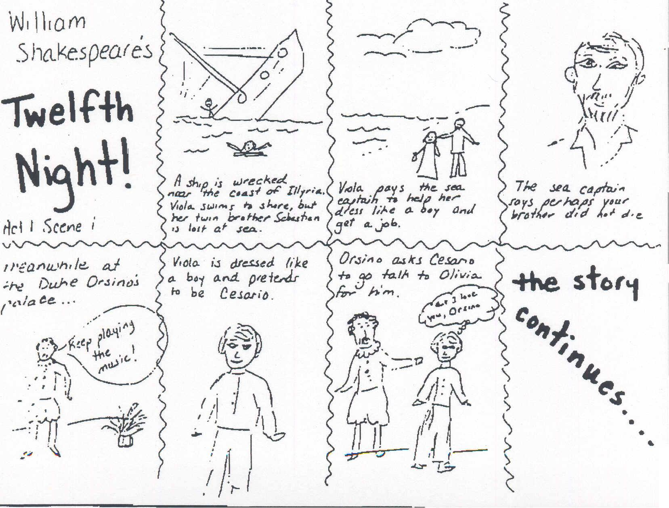

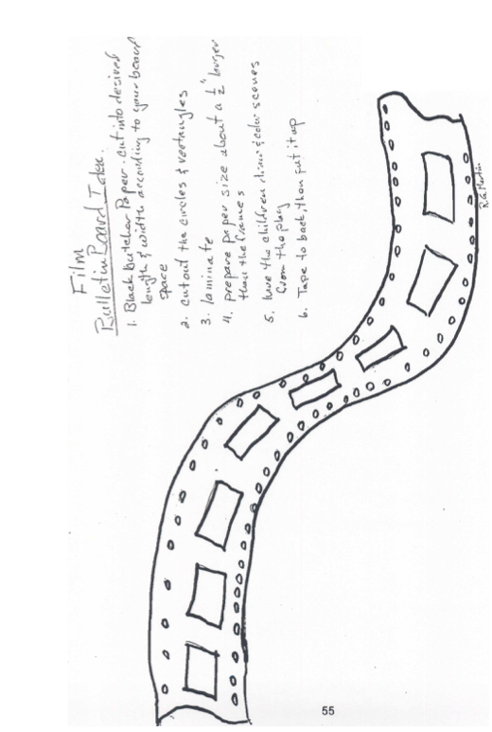

DAY 10

Grades 3, 4 and 5

Lesson: Movie Poster for Play

Additional Study – Movie Poster
Students show their knowledge about the classic Shakespeare story by creating a movie poster to promote a fictitious movie version of the play. Each poster should include a flashy title, reference to William Shakespeare, a short summary of the story, actors, and the parts they portray, rating, and illustration.

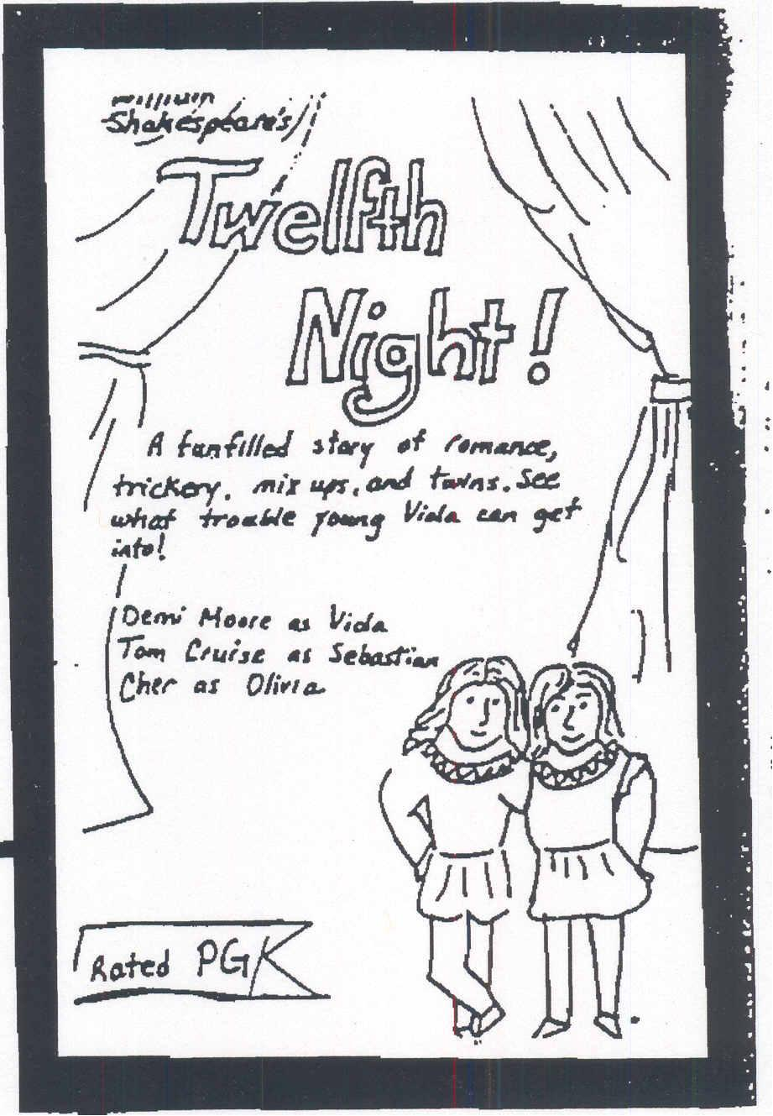

DAY 11

Grades 3, 4 and 5

Scheduled Performance and Workshop (Kingsmen Shakespeare Company)*

*Performance and Workshop must be scheduled at the beginning of the school year by the Principal.

KINGSMEN SHAKESPEARE FESTIVAL COMPANY

For the past several summers, Kingsmen Shakespeare Festival has entertained thousands of Southern California residents in performances of free Shakespeare plays held on the California Lutheran University campus grounds. Performance survey cards have shown that the audience has been comprised of families and friends from all professions and vocations. Those enjoying the festival have traveled from as close as walking distance to as far away as Santa Monica and the West Valley.

The success of these performances has lead Kingsmen to explore an educational touring division. To that end, Kingsmen has created an educational outreach program called Shakespeare Educational Tour or simply put "S.E.T." The workshops and performances at the school will be created by actors, directors and producers who, with teacher guidance, will create exciting and engrossing shows that brings to life the material taught in this unit.

Kingsmen Shakespeare Festival acting troupe workshop and performances are an extra added benefit to the Shakespeare teaching unit.
The workshops will be organized on the day of the performance. One member of the acting troop will conduct each workshop. The workshops will be organized during regular classroom periods. The variables regarding the size of the student body and how many workshops to be held at the school will be decided on by the specific needs of each school.

Workshop outlines for grades 3, 4, and 5.

The purpose of these workshops is to introduce the students to the Theater as well as to Shakespeare.

GENERAL THEATRE COMPONENTS ­ as they relate to the school (Actor to explain)
1) Producer ­ Principal
2) Director­ Teacher
3) Stage Manager ­ Teacher Assistant
4) Actors ­ Students
5) Script ­ Reading book

VISUAL AIDS
1) Stage light (rigged for a 100-watt bulb) and different gels
2) Lightning sheet
3) Stonn (stone) box
4) Theatre Posters ­ preferably of these plays
5) They have seen pictures of the Globe, show pictures of a modem theatre.
6) Theatre tickets ­ reserved seating (different than movie tickets)
7) Theatre program
8) Theatre make­up (spirit gum and hair)
9) A costume from the play - actor in under­dressing of the character he is going to play, puts on the balance of the costume while speaking to the class. Bring a second costume from the play.

GENERAL QUESTIONS AND ANSWERS
The teachers will advise the actors in advance as to specific topics or questions that have come up during the teaching of the play that the actor should elaborate on or clarify.

A Midsummer Night's Dream (Grade 3)

1. Introduce mystery and fairies ­ while putting on Puck's ears
2. Talk about Shakespeare's garden. Then recite Oberon's "I know a bank where the wild thyme blows"
3. Poetry ­ Green Eggs and Ham (stress the beat)
4. Puck "If we shadows have offended," (Interact with a few students ­ go around the room saying the lines to the children)

The Tempest (Grade 4)
1. Introduce magic and Ariel­ Sing "Full fathom five"
2. Children use lightning sheet. stone box. and flash light to "perform" the "tempest"
3. Poetry ­ Green Eggs and Ham (stress the beat)
4. Combine "noise" and poetry in performing caliban's sounds of the island speech. Explain the speech. Exaggerate it when reciting, the repeat it properly.

Twelfth Night or What You Will (Grade 5)
1. Introduce Feste and importance of music in the play, while putting on a Feste's beard.
2. The poetry ­ Green Eggs and Ham (stress the beat)
3. Feste's "O mistress mine. where are you roaming?
(Interact with a few students ­ go around the room saying the lines to the children)
4. Children use lightning sheet. stone box, and flash light to "perform" the storm that sank Viola's and Sebastian's ship. (Actor ­ recite Captain's speech).

Reference Materials

Grades 3, 4 and 5

- Reference Books
- Computer Software
- Internet Sites

Wm. Shakespeare, J Twelfth Night, Cambridge School Shakespeare, Cambridge University Press, 1993 ISBN 0­52143536­6 Urden, LOIS, Shakespeare Can Be Fun: 1 Z" Night for Kids, A Firefly Book, 1997 ISBN ~8753­233­Q
Shakespeare Can Be Fun: A Midsummer Night's Dream for Kids, A Firefly Book, 1997 ISBN 1­55209­1244
Shakespeare Can Be Fun: Romeo and Juliet for Kids, A Firefly Book, 1998 ISBN 1­55209­229­1
Shakespeare Can Be Fun: A Child's Portrait of Shakespeare, A Firefly Book, 1995 ISBN 0­ 88753­261­6
Chirinina, Alain (Retold), Shakespeare's Play in the Classroom: A Midsummer Night's Dream, Good, Apple a division of Frank Shaffer's publications, 1997 ISBN 1­56417­991­5
Hood, Christine and Lori Cardoza­Stames (Retold), Shakespeare's Play in the Classroom: 1ih Night, GOod Apple a division of Frank Shaffer's publications, 1998 ISBN 0­7682..0010­5 .
Shakespeare's Play in the Classroom: The Tempest, Good Apple a division of Frank Shaffer's publications, 1998 ISBN 0­7682­0009­1
Other excellent books
O'Brien, Peggy (ed.). Shakespeare Set Free (series) Washington Square Press, 1994, ISBN 0­671­76048­3 (etc.)
Stevenson, Burton (ed.). The Folger Book of Shakespeare Quotations, Folger Books, 1973 (and later printings) ISBN 0­0­918016­00­2
Macrone, Michael, Brosh Up Your Shakespeare!, HarperPerennial, 1990, ISBN 0­06­272018­X Epstein, Nonie, The Friendly Shakespeare, A WinokurlBoates Book (Viking), 1'993, ISBN 0­67084447­0
Lamb, Chanes and Mary, Tales From Shakespeare, Signet Classics ISBN 0­451­52391­1 (This book is in public domain and is published by several publishing companies.)
Goddard, Harold, The Meaning of Shakespeare, University of Chicago Press, ISBN 022630041­2 (volume 1) and ISBN 022630042­0 (volume 2) .
Schoenbaum, S. (ed). Shakespeare. The Globe and The World, Folger Shakespeare Library, Oxford University Press, 1979, ISBN 0­19­502646­2
Computer Software
There are many software programs written on William Shakespeare. Here are a few to get you started. These and other CD's can be found in Educational Software Catalogues.
Shakespeare's Theatre. by Clearvueleav (Educational Resources MACIVVIN CD Home #904201) Shakespeare's London, by Clearvueleav (Ed!Jcational Resources MACMfIN CD Home #593341)
The Time, Ufe and Works of Shakespeare, by aearvueleav (Educational Resources MACIWIN CD Home #53431L)
(3 set CD's) British Literature: William Shakespeare; Shakespeare's London; Shakespeare's Theatre. by Zane Publishing
1950 Stemmons, Suite 4044 Dallas, TX 75207­3109 (214) 746­5555 http://www.zane.com
Macbeth, by Voyager (in the Educational Software Institute Catalogue 5986­MW­CD)
BBC Shakespeare on CD­ROM Series: A Midsummer Night's Dream, ISBN Windows Q­Q73­31976­8 MAC Q­Q73­ 31970­9 The Tempest, ISBN Windows Q­Q73­3197~ MAC Q­Q73­31972­5 Romeo and Juliet, ISBN Windows Q­Q73­31973­3 MAC Q­Q73­31967­9 Macbeth, ISBN Windows ().673­31974­1 MAC Q­Q73­31968­7 Julius Caesar, ISBN Windows Q­Q73­31977­6 MAC Q­Q73­3197­7 Hamlet. ISBN Windows Q­Q73­31975­X MAC Q­Q73­31969­5
All can be purchased in the Scott Foresman­Addison Wesley catalogue 1­800­552­2259
A few excellent educational software distributors: Scholastic Inc. (Concentrates on lower grades) 555 Broadway New York, NY 10012­3999
1­800­724­6527 www.scholastic.com
Educational Resources 1550 Executive Drive P.O. Box 1900 Elgin, IL 60121­1900 1­ 800­624­2926 www.edresources.com
Learning Services P.O Box 10636 Eugene, OR 97440­2636 1­800­ 877­9378 www.leamserv.com
Educational Software Institute 4213 South 94th Street Omaha, NE 68127 1­800­955­ 5570 www.edsoflcom
Forest Technologies 1­800­544­3356 www.ForestTech.com
Internet Sites: There are more sites regarding Shakespeare than you can count Here are just a few that do have educational information. Shakespeare in the Classroom: www.ietlink.netl­massii/shakes
Shakespeare Magazine: www.shakesDearemaaazine.com Wm. Shakespeare and The Internet: http://daphne.palomar.edu/shakesDeare
Shakespeare's Birthplace Trust www.shakesDeare.ora.uk
Shakespeare Globe USA: httD://www.shakesDeare.uil.ic.edu/ The Folger Shakespeare Library: http://www.folaer.edu

